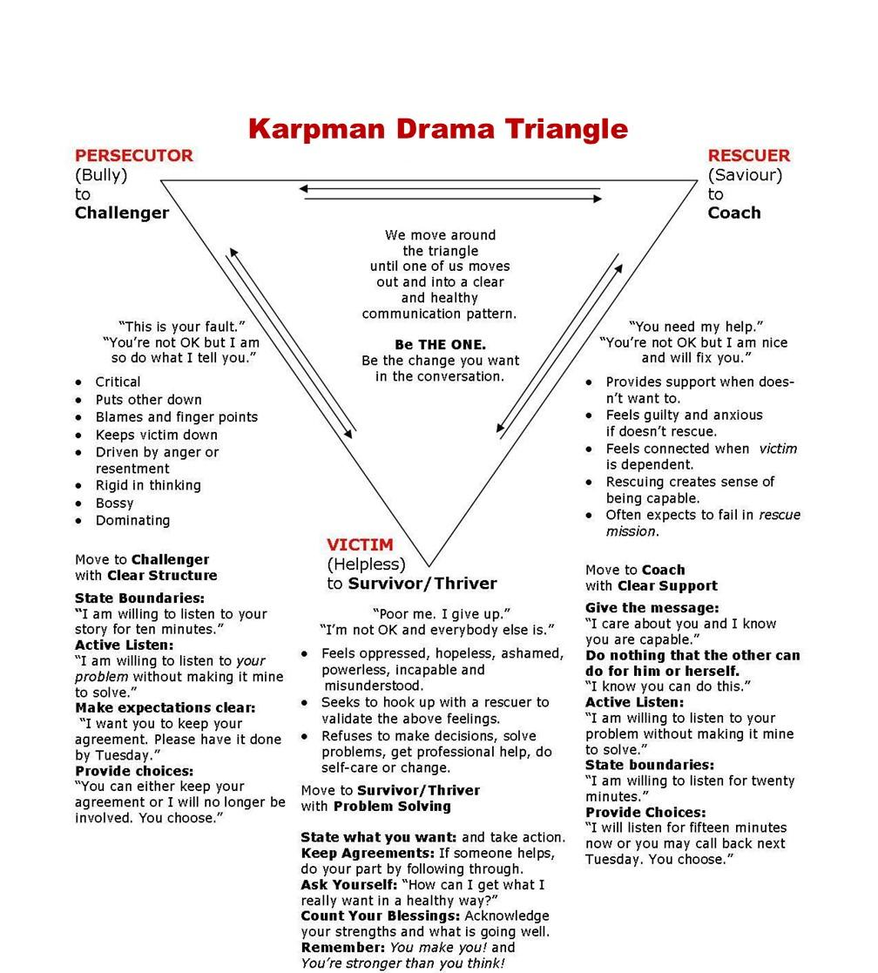

How the Karpman Drama Triangle Relationship Unfolds

A Rescuer is often drawn to a Victim because:
- The Victim’s distress activates the Rescuer’s sense of purpose or identity (“I’m needed,” “I can help”).
- Helping allows the Rescuer to feel competent, valued, or in control
- These two experiences can temporarily compensate for a fear of abandonment, rejection, shame, inadequacy etc.
- The Victim may (consciously or not) signal helplessness, inviting intervention

This creates a subtle agreement:
- Victim: “I can’t handle this”
- Rescuer: “I’ll take care of it for you”

The shift to Persecutor
Over time, the Rescuer may:
- Take on too much responsibility
- Neglect their own needs or boundaries
- Begin to feel unappreciated, exhausted, or trapped
When that burden builds, the Rescuer can flip into the Persecutor role, expressing:
- Frustration (“Why can’t you do this yourself?”)
- Blame or criticism
- Withdrawal of support, often abruptly

The cycle becomes:
- Rescue → over-functioning
- Resentment builds
- Shift to Persecutor → blame/anger
- Victim may then feel attacked, reinforcing their helplessness (and the cycle continues)

The triangle is maintained by imbalanced responsibility:
- The Rescuer over-functions
- The Victim under-functions
- The Persecutor reacts to the strain of that imbalance and seeks disconnection for relief. Unknowingly creates a self-fulfilling prophecy of rejection or abandonment.

